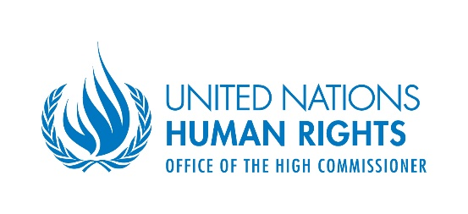 |  | 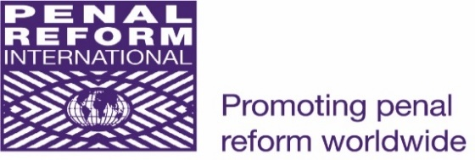

THE ROLE OF CIVIL SOCIETY IN ARMENIA’S CRIMINAL JUSTICE SYSTEM

Public Discussion

12:00 – 12:15  12:15 – 12:30 | Registration of participants  Opening remarks  Larisa Minasyan, Open Society Foundations – Armenia, Executive Director  Miranda Merkviladze, Penal Reform International – South Caucasus Office, Project Coordinator
Moderator
David Amiryan, Open Society Foundations – Armenia, Deputy Director for Programming

12:30 – 13:40 | National Preventive Mechanism (NPM) in Armenia  Arman Tatoyan, Human Rights Defender of RA  HRD as the National Preventive Mechanism in Armenia referred to UN OPCAT  Miranda Merkviladze, Penal Reform International – South Caucasus Office, Project Coordinator  Improving Civil Society’s Engagement in Strengthening National Preventive Mechanism’s Capacity for an Effective Prevention of Torture in Places of Detention in Armenia  Civil Society against Torture  Hayk Alumyan, Justice Group Member, Attorney  RA legislative regulations referred to UN OPCAT toward absolute prohibition of torture  Davit Khachaturyan, Justice Group Member, expert, Ph.D,  Safeguards against torture in Criminal Justice of Armenia  Avetik Ishkhanyan, Justice Group Member, Armenian Helsinki Committee, President  Current situation and perspectives to prevent torture in compliance with international obligations
13:40 – 14:40 | Discussion, Q&A
14:40 – 15:00 | Closing Remarks

Draft Agenda

June 24, 2016
Best Western Congress Hotel, Ball room
1st Italy Street, Yerevan

